

***DATABASE MANAGEMENT SYSTEM***

PROJECT REPORT:

*Organ Donation and Procurement Network Management System*

***SUBMITTED BY:***

SANCHI SINGH

2021UCS1565

***PROBLEM STATEMENT:***

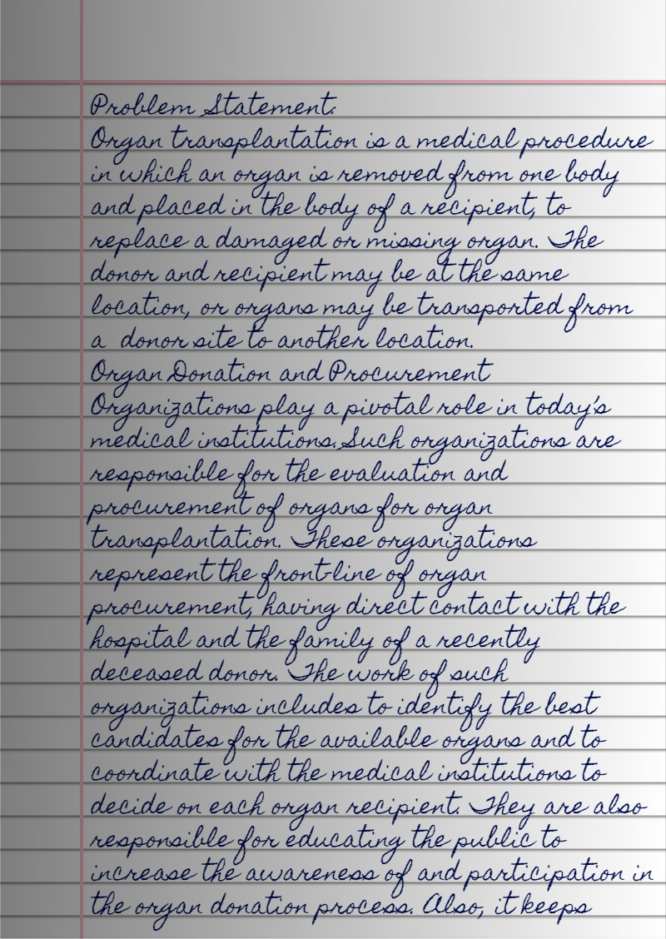

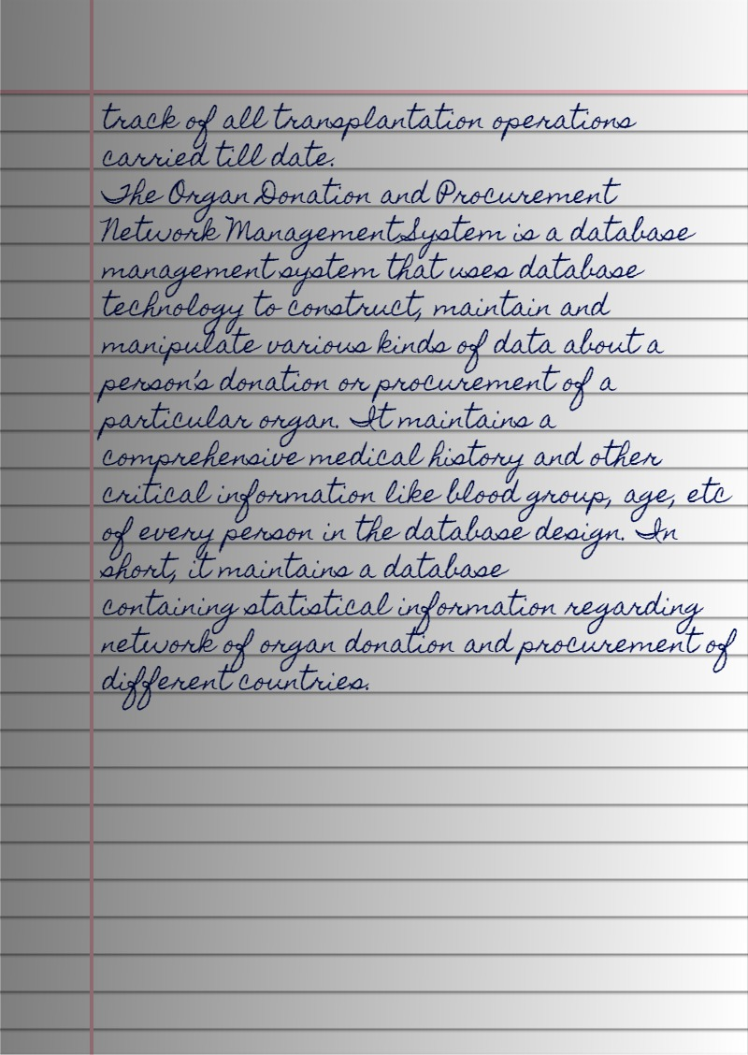

*REQUIREMENT ANALYSIS:*

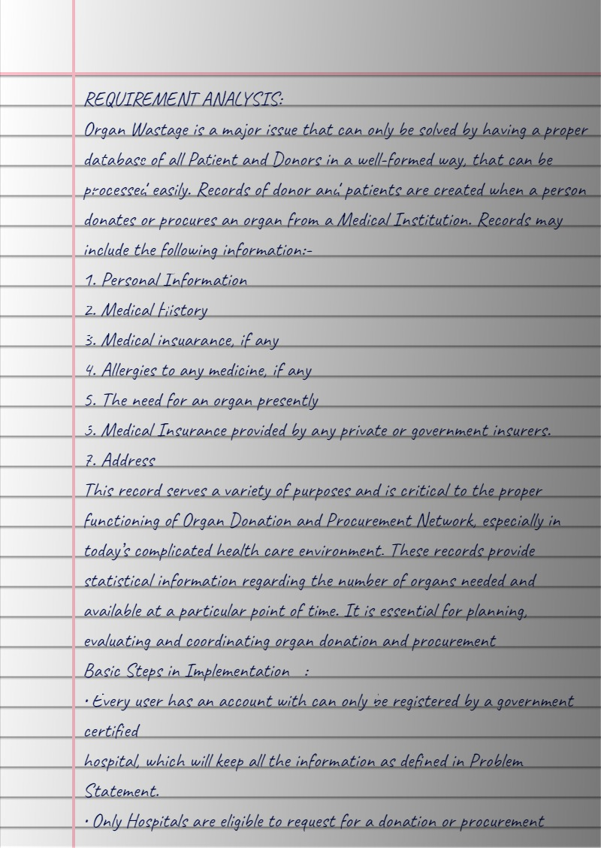

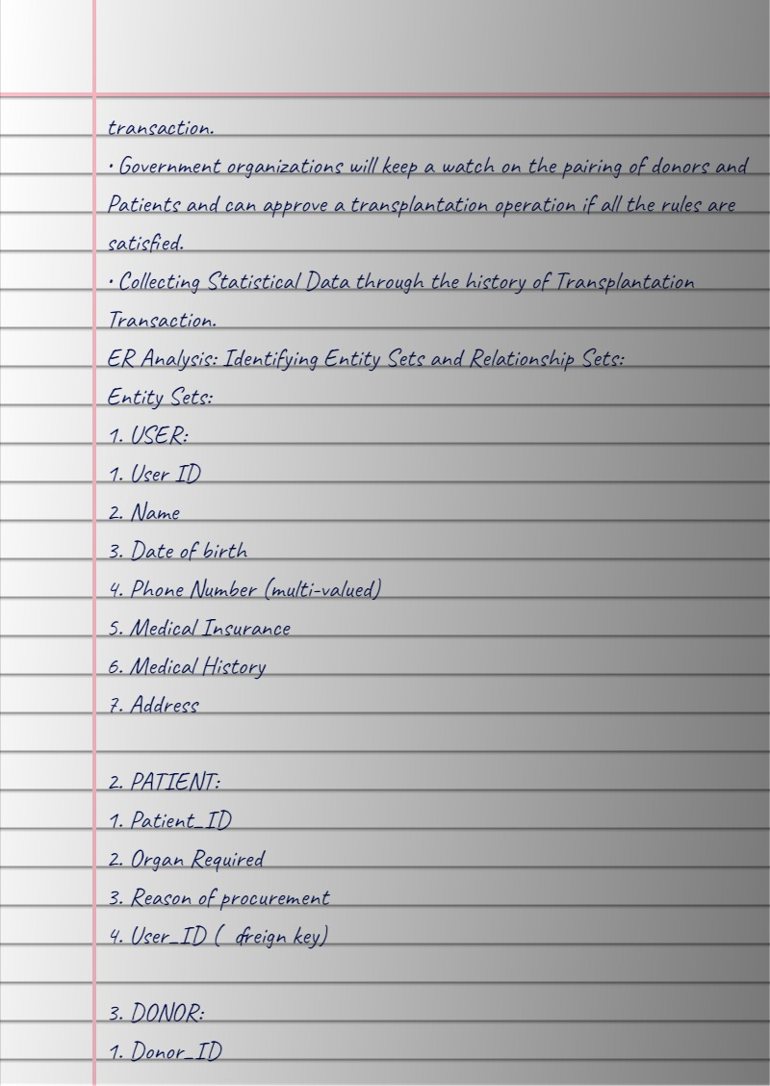

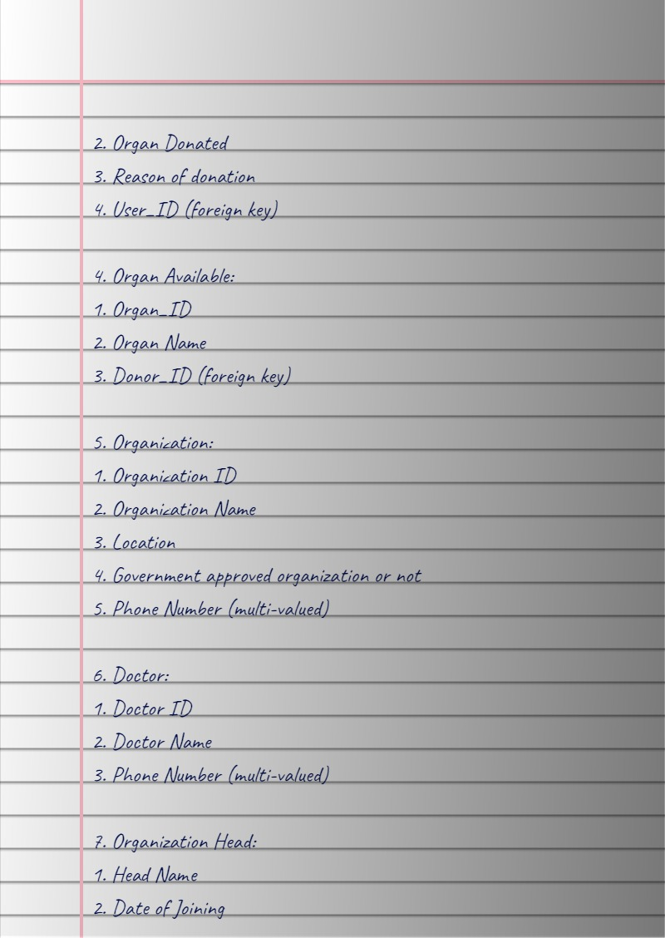

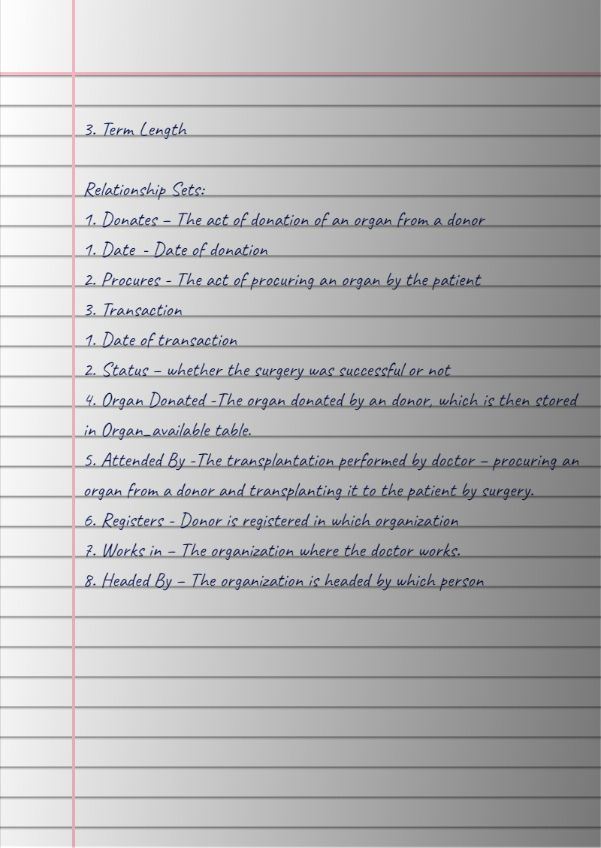

***FUNCTIONAL DEPENDENCIES:***

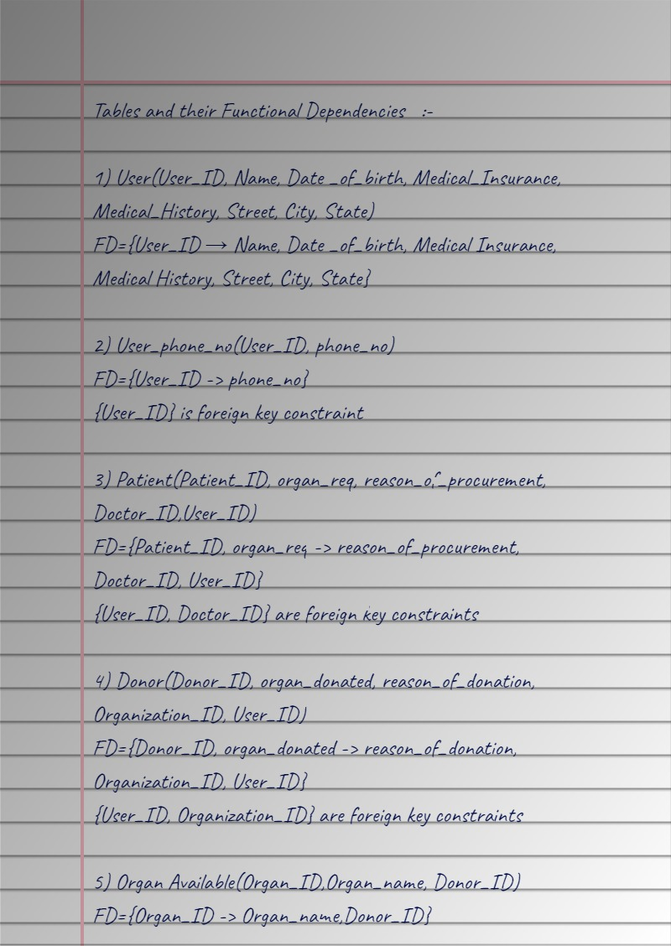

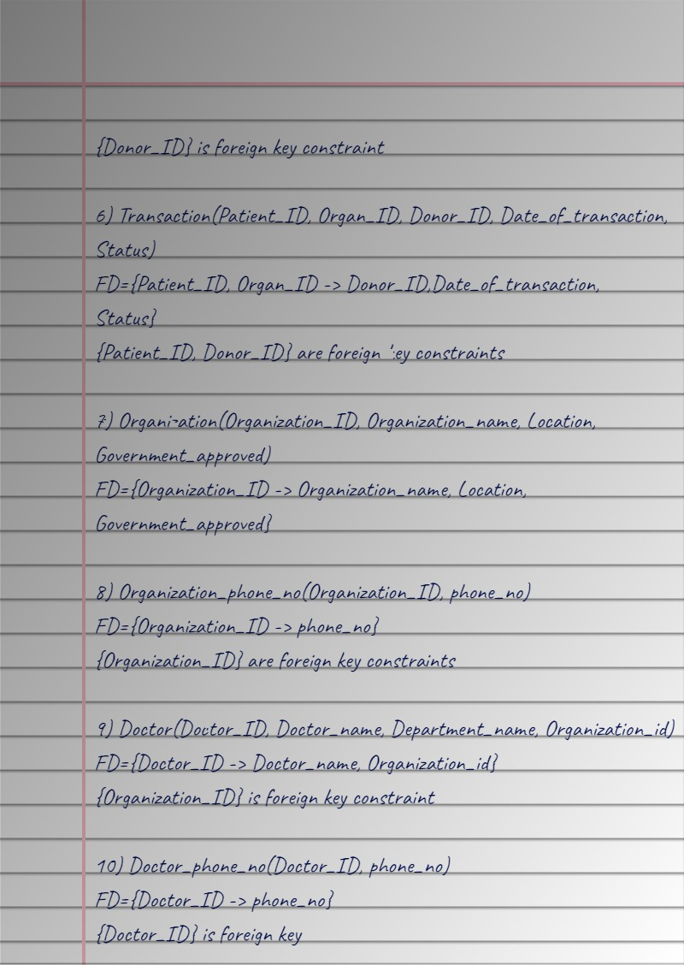



*ER MODEL:*

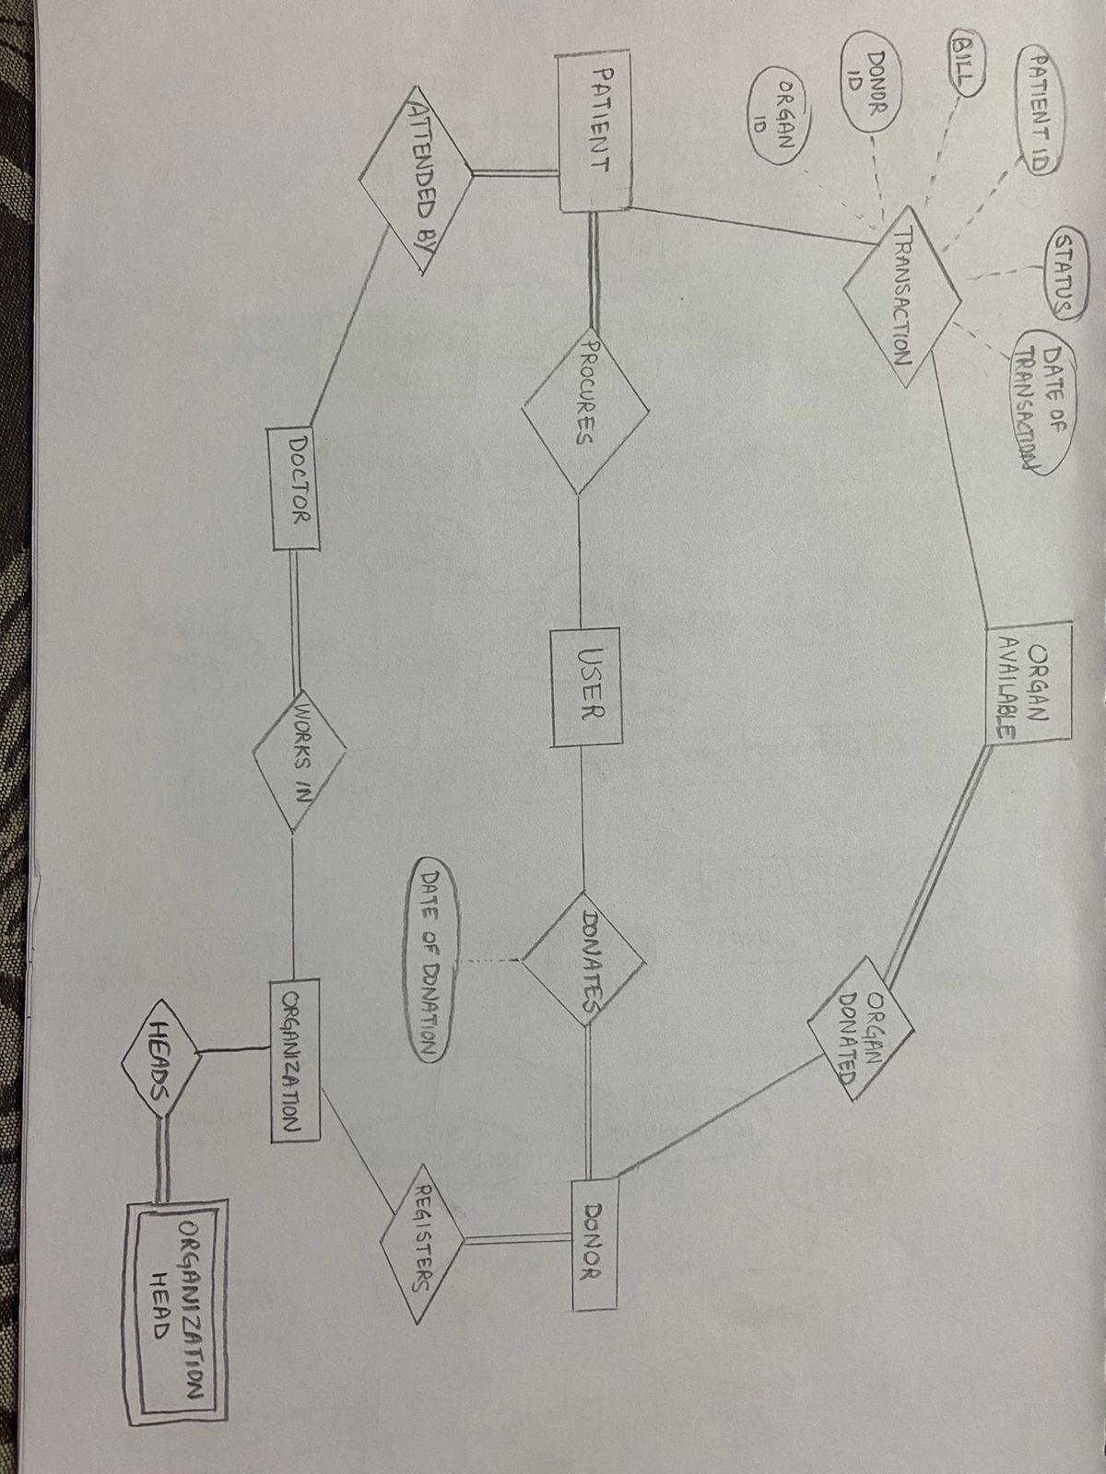

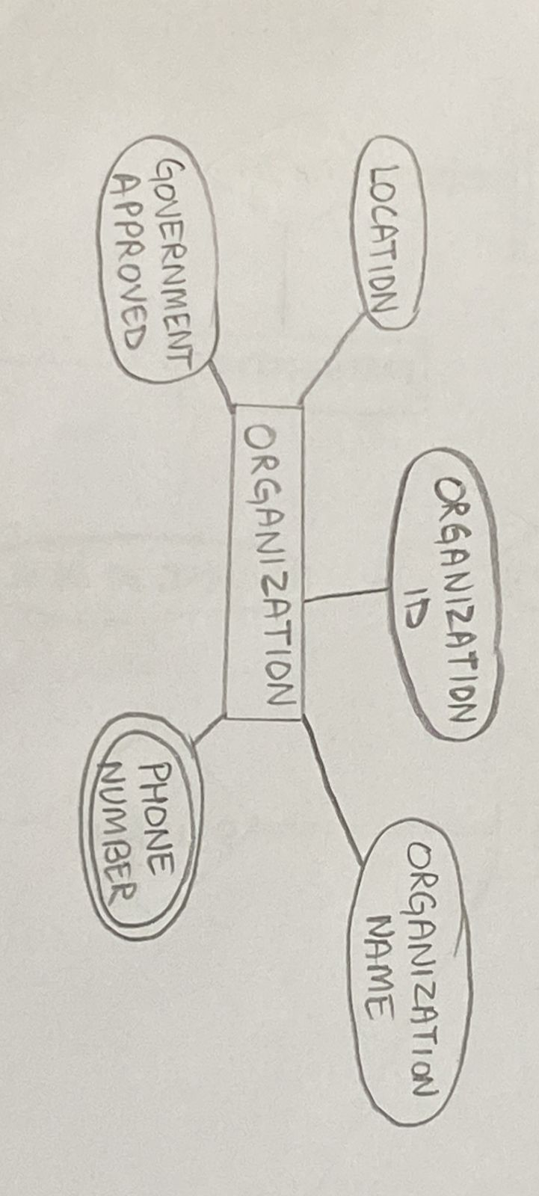

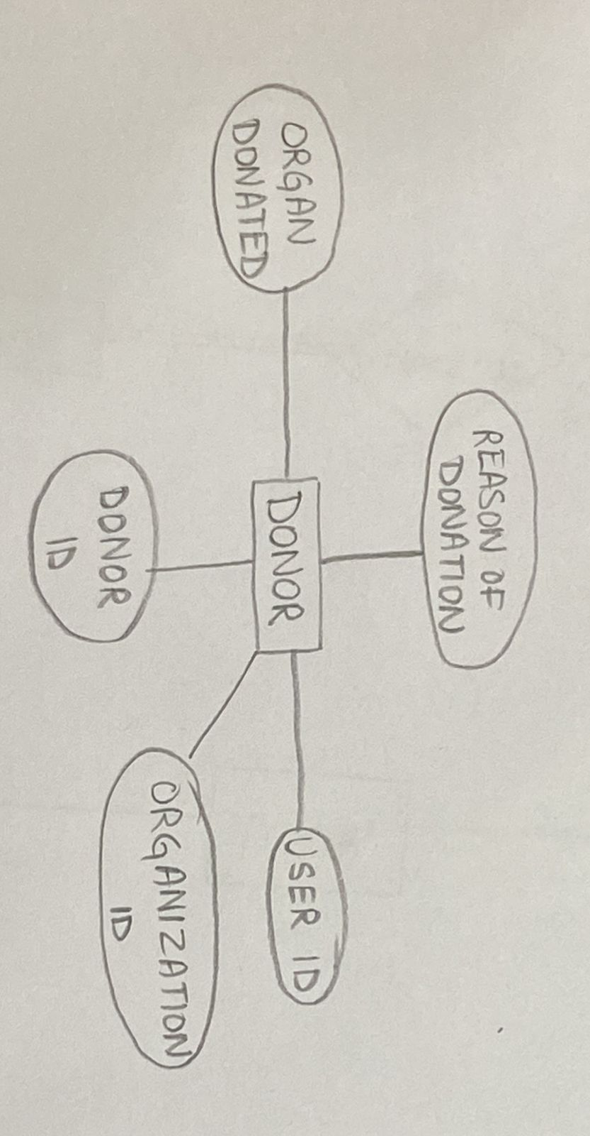

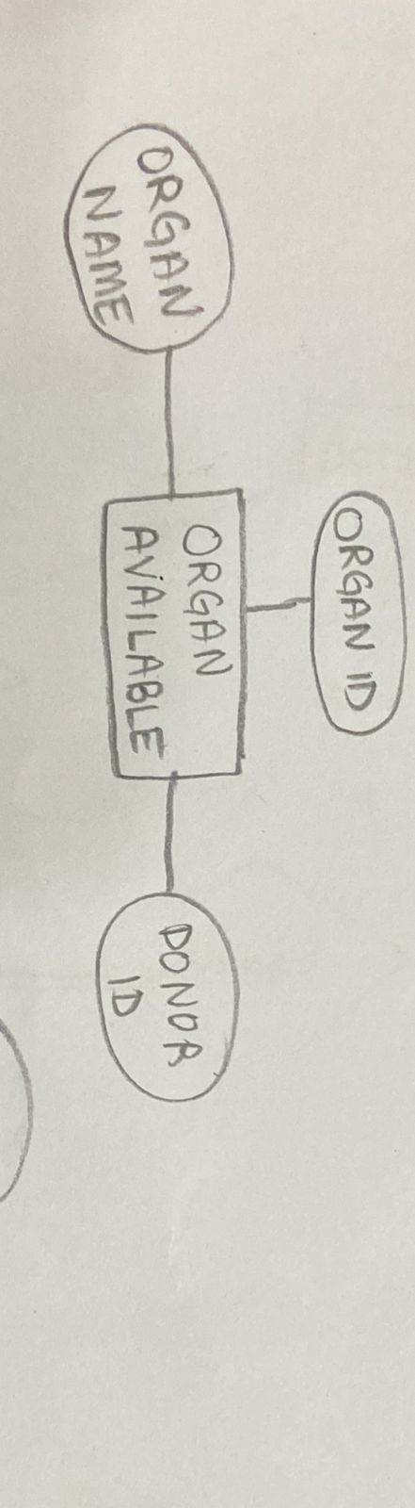

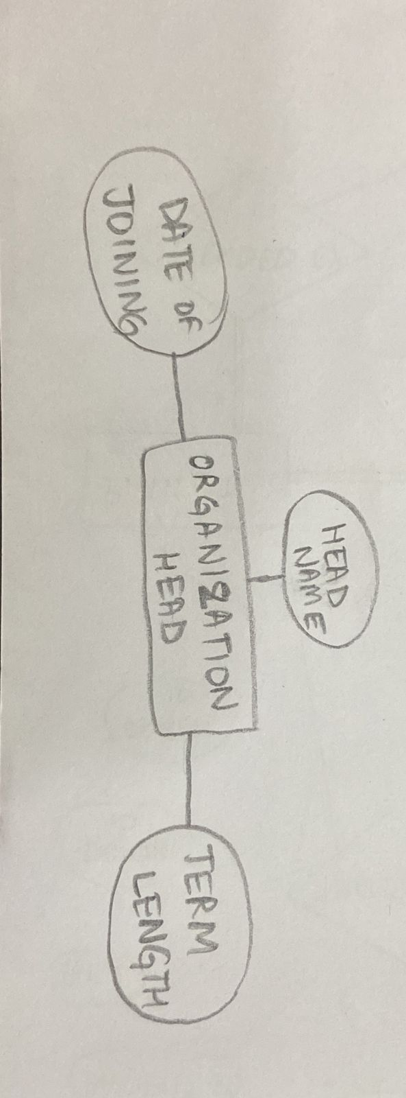

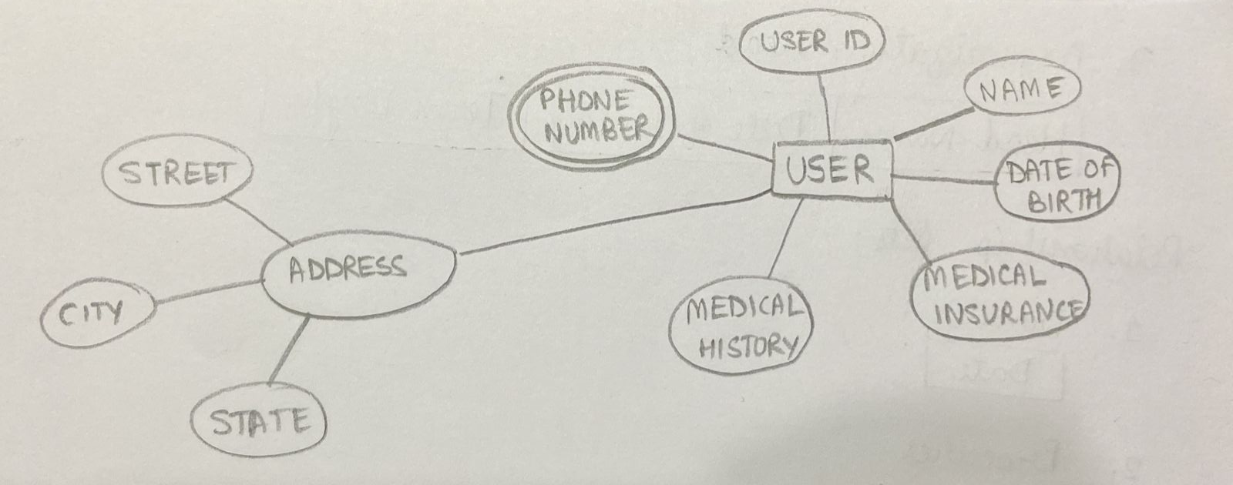

*RELATIONAL SCHEMA:*

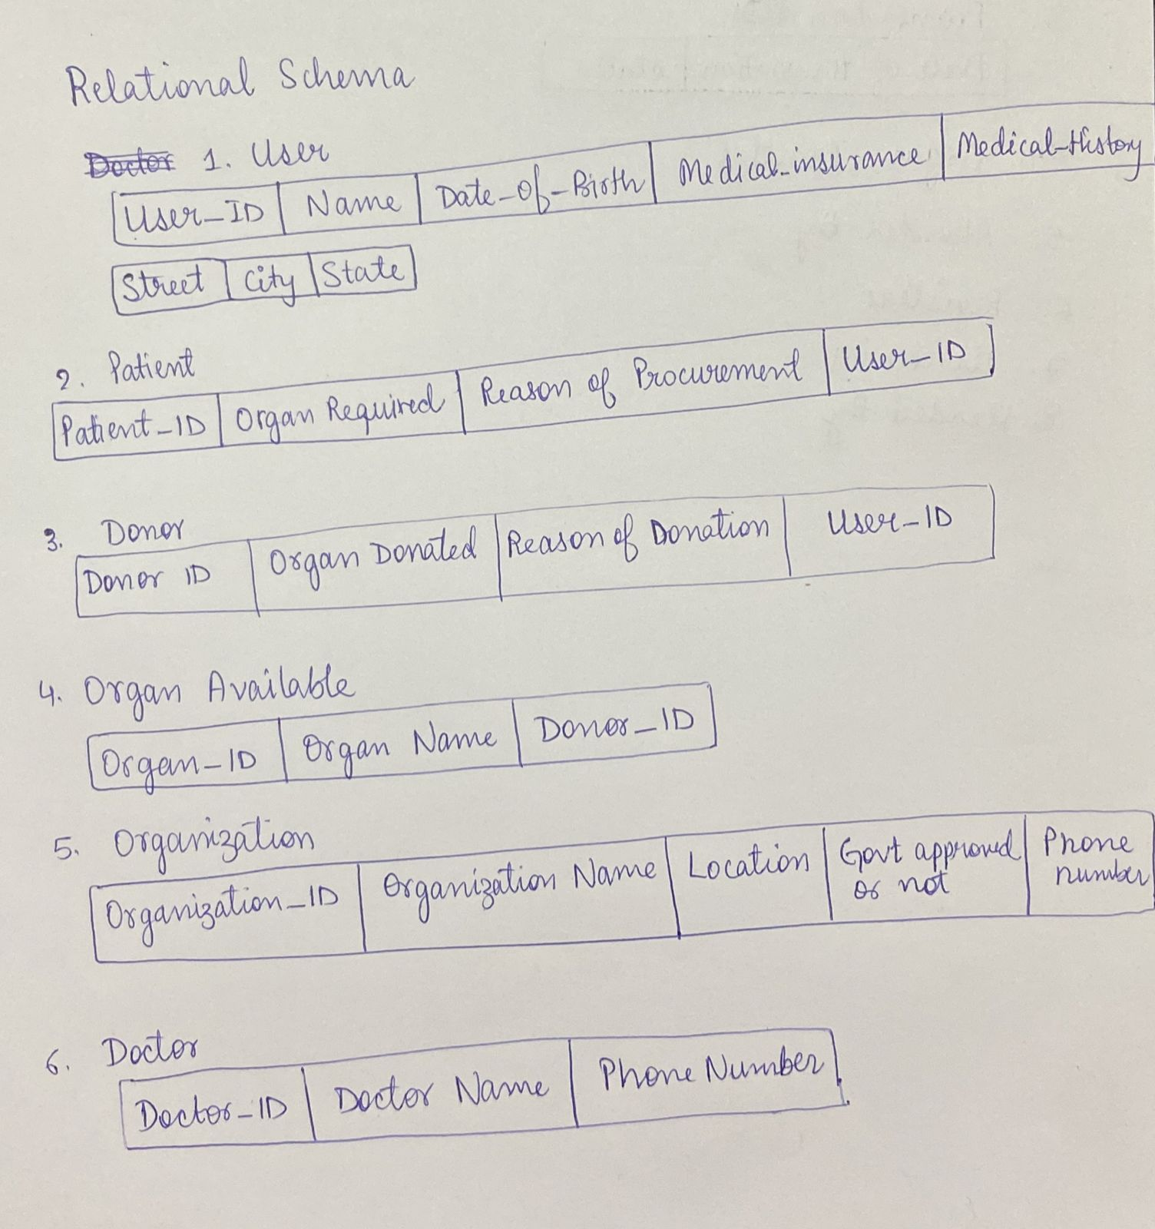

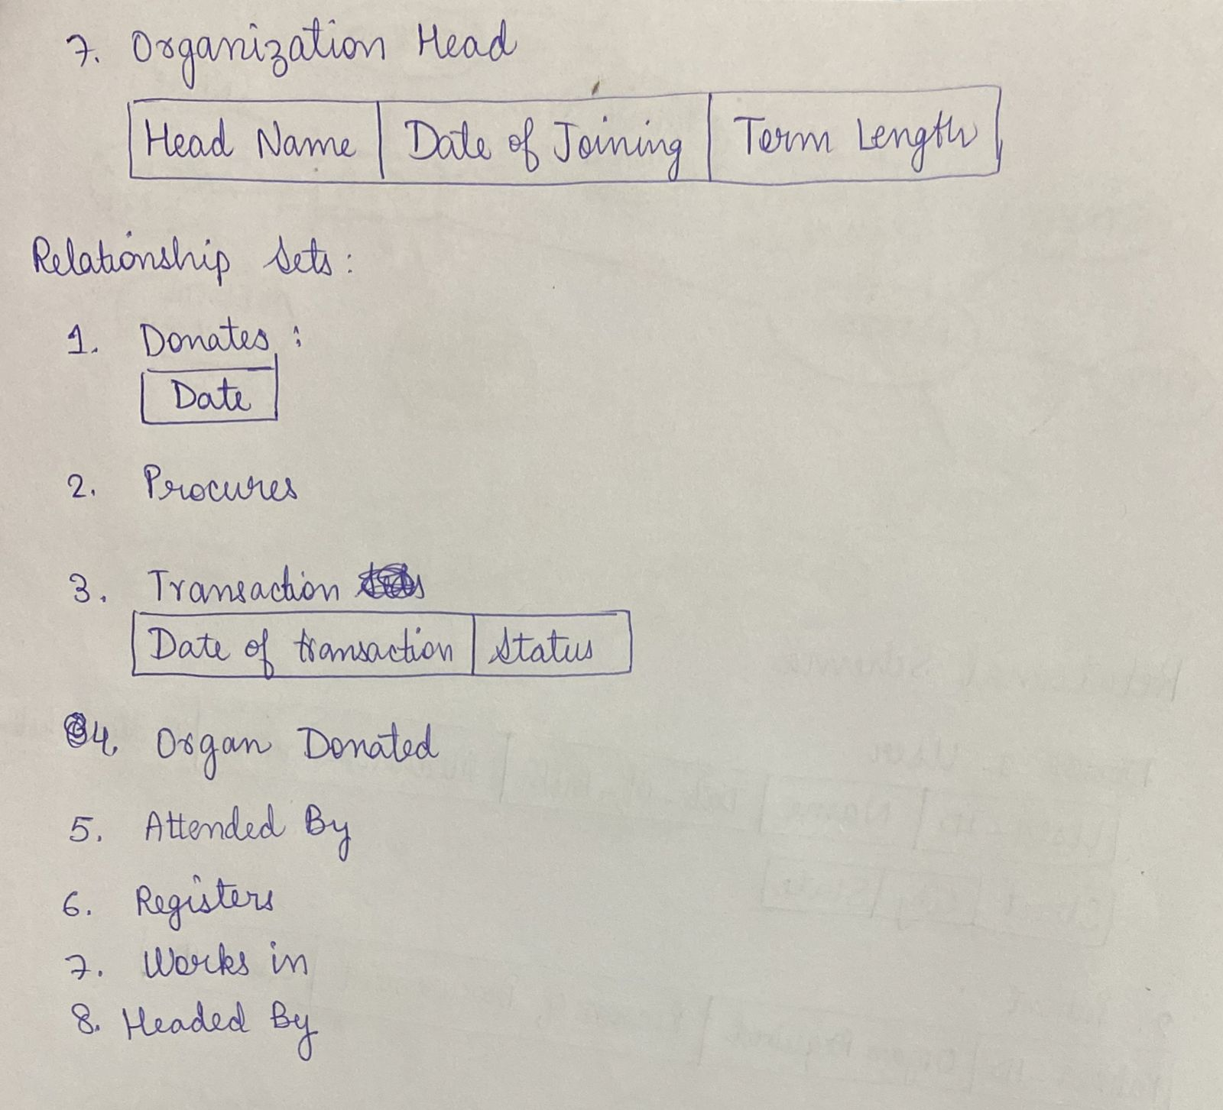

*CREATE TABLE QUERIES IN PYTHON:*

import mysql.connector

mydb = mysql.connector.connect(

  host='localhost',

  user='root',

  password='0212',

  database = 'DBMS_PROJECT'

)

mycursor=mydb.cursor()

mycursor.execute("CREATE TABLE login( username VARCHAR(20) NOT NULL), password VARCHAR(20) NOT NULL")

sql="INSERT INTO login (username,password) VALUES (%s,%s)"

val=("admin","admin")

mycursor.execute(sql, val)

mycursor.execute("""CREATE TABLE User(

    User_ID int NOT NULL PRIMARY KEY,

    Name varchar(20) NOT NULL,

    Date_of_Birth date NOT NULL,

    Medical_insurance int,

    Medical_history varchar(20),

    Street varchar(20),

    City varchar(20),

    State varchar(20),

    )""")

mycursor.execute("""CREATE TABLE User_phone_no(

    User_ID INT NOT NULL PRIMARY KEY,

    phone_no VARCHAR(15),

    FOREIGN KEY(User_ID) REFERENCES User(User_ID) ON DELETE CASCADE)""")

mycursor.execute("""CREATE TABLE Organization(

  Organization_ID int NOT NULL,

  Organization_name varchar(20) NOT NULL,

  Location varchar(20),

  Government_approved int, # 0 or 1

  PRIMARY KEY(Organization_ID)

)""")

mycursor.execute("""CREATE TABLE Doctor(

  Doctor_ID int NOT NULL,

  Doctor_Name varchar(20) NOT NULL,

  Department_Name varchar(20) NOT NULL,

  organization_ID int NOT NULL,

  FOREIGN KEY(organization_ID) REFERENCES Organization(organization_ID) ON DELETE CASCADE,

  PRIMARY KEY(Doctor_ID)

)""")

mycursor.execute("""CREATE TABLE Patient(

    Patient_ID int NOT NULL,

    organ_req varchar(20) NOT NULL,

    reason_of_procurement varchar(20),

    Doctor_ID int NOT NULL,

    User_ID int NOT NULL,

    FOREIGN KEY(User_ID) REFERENCES User(User_ID) ON DELETE CASCADE,

    FOREIGN KEY(Doctor_ID) REFERENCES Doctor(Doctor_ID) ON DELETE CASCADE,

    PRIMARY KEY(Patient_Id, organ_req)

)""")

mycursor.execute(""" CREATE TABLE Donor(

  Donor_ID int NOT NULL,

  organ_donated varchar(20) NOT NULL,

  reason_of_donation varchar(20),

  Organization_ID int NOT NULL,

  User_ID int NOT NULL,

  FOREIGN KEY(User_ID) REFERENCES User(User_ID) ON DELETE CASCADE,

  FOREIGN KEY(Organization_ID) REFERENCES Organization(Organization_ID) ON DELETE CASCADE,

  PRIMARY KEY(Donor_ID, organ_donated)

)""")

mycursor.execute("""CREATE TABLE Organ_available(

  Organ_ID int NOT NULL AUTO_INCREMENT,

  Organ_name varchar(20) NOT NULL,

  Donor_ID int NOT NULL,

  FOREIGN KEY(Donor_ID) REFERENCES Donor(Donor_ID) ON DELETE CASCADE,

  PRIMARY KEY(Organ_ID)

)""")

mycursor.execute("""CREATE TABLE Transaction(

  Patient_ID int NOT NULL,

  Organ_ID int NOT NULL,

  Donor_ID int NOT NULL,

  Date_of_transaction date NOT NULL,

  Status int NOT NULL, #0 or 1

  FOREIGN KEY(Patient_ID) REFERENCES Patient(Patient_ID) ON DELETE CASCADE,

  FOREIGN KEY(Donor_ID) REFERENCES Donor(Donor_ID) ON DELETE CASCADE,

  PRIMARY KEY(Patient_ID,Organ_ID)

)""")

mycursor.execute("""CREATE TABLE Organization_phone_no(

  Organization_ID int NOT NULL,

  Phone_no varchar(15),

  FOREIGN KEY(Organization_ID) REFERENCES Organization(Organization_ID) ON DELETE CASCADE

)""")

mycursor.execute("""CREATE TABLE Doctor_phone_no(

  Doctor_ID int NOT NULL,

  Phone_no varchar(15),

  FOREIGN KEY(Doctor_ID) REFERENCES Doctor(Doctor_ID) ON DELETE CASCADE

)""")

mycursor.execute("""CREATE TABLE Organization_head(

  Organization_ID int NOT NULL,

  Employee_ID int NOT NULL,

  Name varchar(20) NOT NULL,

  Date_of_joining date NOT NULL,

  Term_length int NOT NULL,

  FOREIGN KEY(Organization_ID) REFERENCES Organization(Organization_ID) ON DELETE CASCADE,

  PRIMARY KEY(Organization_ID,Employee_ID)

)""")

mycursor.execute("DROP TRIGGER IF EXISTS ADD_DONOR")

qrystr="""CREATE TRIGGER ADD_DONOR

AFTER INSERT ON DONOR

FOR EACH ROW BEGIN INSERT INTO Organ_available(Organ_name, Donor_ID)

VALUES (new.organ_donated, new.Donor_ID); end;"""

mycursor.execute(qrystr)

qry2="""CREATE TRIGGER ADD_DONOR_LOG AFTER INSERT

 on Donor for each row begin insert into log values

  (now(), concat("Inserted new Donor", cast(new.Donor_Id as char))); end;"""

mycursor.execute("""create trigger UPD_DONOR_LOG

after update

on Donor

for each row

begin

insert into log values

(now(), concat("Updated Donor Details", cast(new.Donor_Id as char)));

end;""")

mycursor.execute("""create trigger DEL_DONOR_LOG

after delete

on Donor

for each row

begin

insert into log values

(now(), concat("Deleted Donor ", cast(old.Donor_Id as char)));

end; """)

mycursor.execute(""" create trigger ADD_PATIENT_LOG

after insert

on Patient

for each row

begin

insert into log values

(now(), concat("Inserted new Patient ", cast(new.Patient_Id as char)));

end; """)

mycursor.execute("""create trigger UPD_PATIENT_LOG

after update

on Patient

for each row

begin

insert into log values

(now(), concat("Updated Patient Details ", cast(new.Patient_Id as char)));

end; """)

mycursor.execute("""create trigger DEL_PATIENT_LOG

after delete

on Donor

for each row

begin

insert into log values

(now(), concat("Deleted Patient ", cast(old.Donor_Id as char)));

end """)

mycursor.execute("""create trigger ADD_TRANSACTION_LOG

after insert

on Transaction

for each row

begin

insert into log values

(now(), concat("Added Transaction :: Patient ID : "

, cast(new.Patient_ID as char),

"; Donor ID : " ,cast(new.Donor_ID as char)));

end """)

mycursor.execute("""INSERT INTO User

 VALUES(10,'Random1','2000-01-01',1,NULL,'Street 1','City 1','State 1')""")

mycursor.execute("""INSERT INTO User

 VALUES(20,'Random2','2000-01-02',1,NULL,'Street 2','City 2','State 2')""")

OUTPUT:

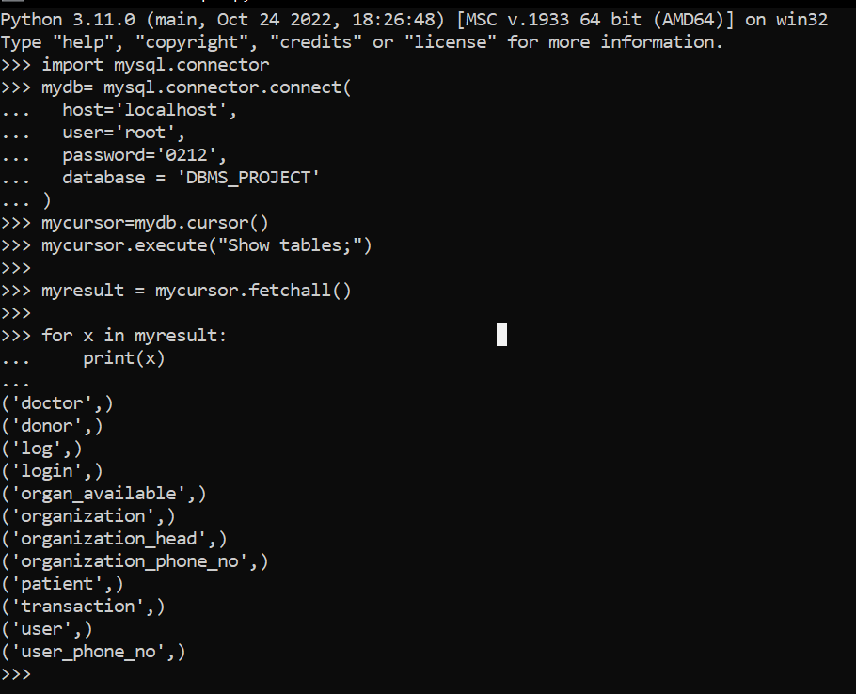

*INSERT VALUE QUERIES IN PYTHON:*

import mysql.connector

mydb = mysql.connector.connect(

  host='localhost',

  user='root',

  password='0212',

  database = 'DBMS_PROJECT'

)

mycursor=mydb.cursor()

sql = """INSERT INTO doctors

 (Doctor_ID,Doctor_Name, Department_Name, organization_ID)

 VALUES (%s, %s,%s,%s)"""

val=[(1,'Doctor-1','Department-1',78),

(2,'Doctor-2','Department-2',10),

(3,'Doctor-3','Department-3',61),

(4,'Doctor-4','Department-4',26),

(5,'Doctor-5','Department-5',11),

(6,'Doctor-6','Department-6',99),

(7,'Doctor-7','Department-7',54),

(8,'Doctor-8','Department-8',44),

(9,'Doctor-9','Department-9',57),

(10,'Doctor-10','Department-10',31),

(11,'Doctor-11','Department-11',5),

(12,'Doctor-12','Department-12',11),

(13,'Doctor-13','Department-13',36),

(14,'Doctor-14','Department-14',22),

(15,'Doctor-15','Department-15',42),

(16,'Doctor-16','Department-16',73),

(17,'Doctor-17','Department-17',80),

(18,'Doctor-18','Department-18',77),

(19,'Doctor-19','Department-19',6),

(20,'Doctor-20','Department-20',87)

]

mycursor.executemany(sql, val)

mydb.commit()

insertdonor="""INSERT INTO donors

(Donor_ID,organ_donated,reason_of_donation,Organzation_ID,User_ID)

VALUES (%s,%s,%s,%s,%s)"""

val1=[

(1,'Heart','Reason-1',97,90),

(2,'Pancreas','Reason-2',79,41),

(3,'Pancreas','Reason-3',1,95),

(4,'Intestine','Reason-4',60,96),

(5,'Kidney','Reason-5',69,72),

(6,'Pancreas','Reason-6',1,89),

(7,'Kidney','Reason-7',51,43),

(8,'Kidney','Reason-8',53,61),

(9,'Heart','Reason-9',57,16),

(10,'Heart','Reason-10',24,50),

(11,'Kidney','Reason-11',8,92),

(12,'Pancreas','Reason-12',64,58),

(13,'Pancreas','Reason-13',28,45),

(14,'Pancreas','Reason-14',10,75),

(15,'Heart','Reason-15',50,53),

(16,'Intestine','Reason-16',27,31),

(17,'Intestine','Reason-17',72,94),

(18,'Intestine','Reason-18',97,7),

(19,'Pancreas','Reason-19',69,67),

(20,'Intestine','Reason-20',40,28),

]

mycursor.executemany(insertdonor, val1)

mydb.commit()

sqlorg="""INSERT INTO Organization

(Organization_ID,Organization_name,Location,Government_approved)

VALUES(%s,%s,%s,%s)"""

val2=[

(1, 'Organization-1','New Delhi',1),

(2, 'Organization-2','Mumbai',0),

(3, 'Organization-3','Kolkata',0),

(4, 'Organization-4','Kolkata',1),

(5, 'Organization-5','Ahmedabad',1),

(6, 'Organization-6','Kolkata',0),

(7, 'Organization-7','Kolkata',0),

(8, 'Organization-8','Ahmedabad',0),

(9, 'Organization-9','Kolkata',1),

(10, 'Organization-10','Ahmedabad',1),

(11, 'Organization-11','Ahmedabad',1),

(12, 'Organization-12','Mumbai',0),

(13, 'Organization-13','Kolkata',0),

(14, 'Organization-14','Ahmedabad',1),

(15, 'Organization-15','Ahmedabad',0),

(16, 'Organization-16','Kolkata',0),

(17, 'Organization-17','Kolkata',1),

(18, 'Organization-18','Mumbai',1),

(19, 'Organization-19','Ahmedabad',1),

(20, 'Organization-20','Ahmedabad',1)

]

mycursor.executemany(sqlorg, val2)

mydb.commit()

sqlpatient="""INSERT INTO Patient

(Patient_ID,organ_req,reason_of_procurement,Doctor_ID,User_ID)

VALUES (%s,%s,%s,%s,%s)"""

val3=[

(1,'Heart','Reason-1',63,48),

(2,'Kidney','Reason-2',62,11),

(3,'Pancreas','Reason-3',72,84),

(4,'Kidney','Reason-4',87,36),

(5,'Heart','Reason-5',44,13),

(6,'Lung','Reason-6',71,52),

(7,'Intestine','Reason-7',63,85),

(8,'Intestine','Reason-8',42,83),

(9,'Lung','Reason-9',41,52),

(10,'Kidney','Reason-10',16,8),

(11,'Kidney','Reason-11',91,95),

(12,'Pancreas','Reason-12',70,58),

(13,'Intestine','Reason-13',81,44),

(14,'Heart','Reason-14',3,94),

(15,'Kidney','Reason-15',94,30),

(16,'Lung','Reason-16',95,97),

(17,'Heart','Reason-17',7,2),

(18,'Kidney','Reason-18',89,82),

(19,'Kidney','Reason-19',25,24),

(20,'Pancreas','Reason-20',11,23)

]

mycursor.executemany(sqlpatient, val3)

mydb.commit()

sqluser="""INSERT INTO User

(User_ID,Name,Date_Of_Birth, Medical_insurance, Medical_history,Street, City, State)

VALUES (%s,%s,%s,%s,%s,%s,%s,%s)"""

val4=[

( 1 ,'Name-1','1978-8-21',1,'NIL','Street-1','New Delhi','Delhi'),

( 2 ,'Name-2','1975-12-10',0,'NIL','Street-2','Mumbai','Maharashtra'),

( 3 ,'Name-3','1976-6-4',0,'NIL','Street-3','Mumbai','Maharashtra'),

( 4 ,'Name-4','1985-10-13',1,'NIL','Street-4','Ahmedabad','Gujarat'),

( 5 ,'Name-5','1983-10-12',1,'NIL','Street-5','Kolkata','West Bengal'),

( 6 ,'Name-6','1977-1-18',1,'NIL','Street-6','Kolkata','West Bengal'),

( 7 ,'Name-7','1976-2-26',0,'NIL','Street-7','New Delhi','Delhi'),

( 8 ,'Name-8','1973-4-12',1,'NIL','Street-8','Mumbai','Maharashtra'),

( 9 ,'Name-9','1976-11-1',0,'NIL','Street-9','Mumbai','Maharashtra'),

( 10 ,'Name-10','1978-11-18',1,'NIL','Street-10','New Delhi','Delhi'),

( 11 ,'Name-11','1975-1-6',1,'NIL','Street-11','Mumbai','Maharashtra'),

( 12 ,'Name-12','1983-11-1',1,'NIL','Street-12','Mumbai','Maharashtra'),

( 13 ,'Name-13','1983-1-9',1,'NIL','Street-13','New Delhi','Delhi'),

( 14 ,'Name-14','1975-10-12',1,'NIL','Street-14','Mumbai','Maharashtra'),

( 15 ,'Name-15','1977-9-23',0,'NIL','Street-15','Ahmedabad','Gujarat'),

( 16 ,'Name-16','1982-11-29',1,'NIL','Street-16','New Delhi','Delhi'),

( 17 ,'Name-17','1974-3-19',0,'NIL','Street-17','Mumbai','Maharashtra'),

( 18 ,'Name-18','1973-10-27',0,'NIL','Street-18','New Delhi','Delhi'),

( 19 ,'Name-19','1980-3-18',0,'NIL','Street-19','Kolkata','West Bengal'),

( 20 ,'Name-20','1978-8-15',1,'NIL','Street-20','Kolkata','West Bengal')

]

mycursor.executemany(sqluser, val4)

mydb.commit()

sqltrans="""INSERT INTO transaction

( Patient_ID, Organ_ID, Donor_ID, Date_of_transaction, Status)

 VALUES (%s,%s,%s,%s,%s)"""

val5=[

( 22,7,7,'2014-9-19',0),

( 97,19,19,'2013-4-30',1),

( 156,154,154,'2017-4-10',1),

( 113,110,110,'2013-9-28',1),

( 73,36,36,'2017-3-27',0),

( 108,28,28,'2015-8-1',0),

( 111,164,164,'2012-4-2',1),

( 86,184,184,'2013-11-11',0),

( 34,106,106,'2014-3-12',1),

( 51,149,149,'2017-1-29',0),

( 69,97,97,'2015-12-21',1),

( 174,77,77,'2013-8-4',0),

( 68,17,17,'2012-5-15',1),

( 32,119,119,'2017-5-22',0),

( 79,76,76,'2015-12-23',0),

( 183,16,16,'2014-3-5',0),

( 60,186,186,'2014-9-2',1),

( 142,44,44,'2016-6-8',1),

( 199,10,10,'2016-9-28',1),

( 109,181,181,'2014-5-22',0)

]

mycursor.executemany(sqltrans, val5)

mydb.commit()

sqlphone="""INSERT INTO User_Phone_no(User_ID, phone_number) VALUES (%s,%s,)"""

val6=[

(1,'Kidney','Reason-1',85,6),

(2,'Pancreas','Reason-2',13,10),

(3,'Heart','Reason-3',44,39),

(4,'Lung','Reason-4',88,49),

(5,'Lung','Reason-5',80,60),

(6,'Intestine','Reason-6',49,66),

(7,'Heart','Reason-7',8,90),

(8,'Heart','Reason-8',44,27),

(9,'Pancreas','Reason-9',39,84),

(10,'Lung','Reason-10',51,66),

(11,'Pancreas','Reason-11',57,40),

(12,'Kidney','Reason-12',11,68),

(13,'Kidney','Reason-13',47,32),

(14,'Intestine','Reason-14',51,43),

(15,'Heart','Reason-15',38,85),

(16,'Lung','Reason-16',32,70),

(17,'Lung','Reason-17',65,69),

(18,'Kidney','Reason-18',21,85),

(19,'Lung','Reason-19',28,58),

(20,'Pancreas','Reason-20',23,68)

]

mycursor.executemany(sqlphone, val6)

mydb.commit()

OUTPUT:

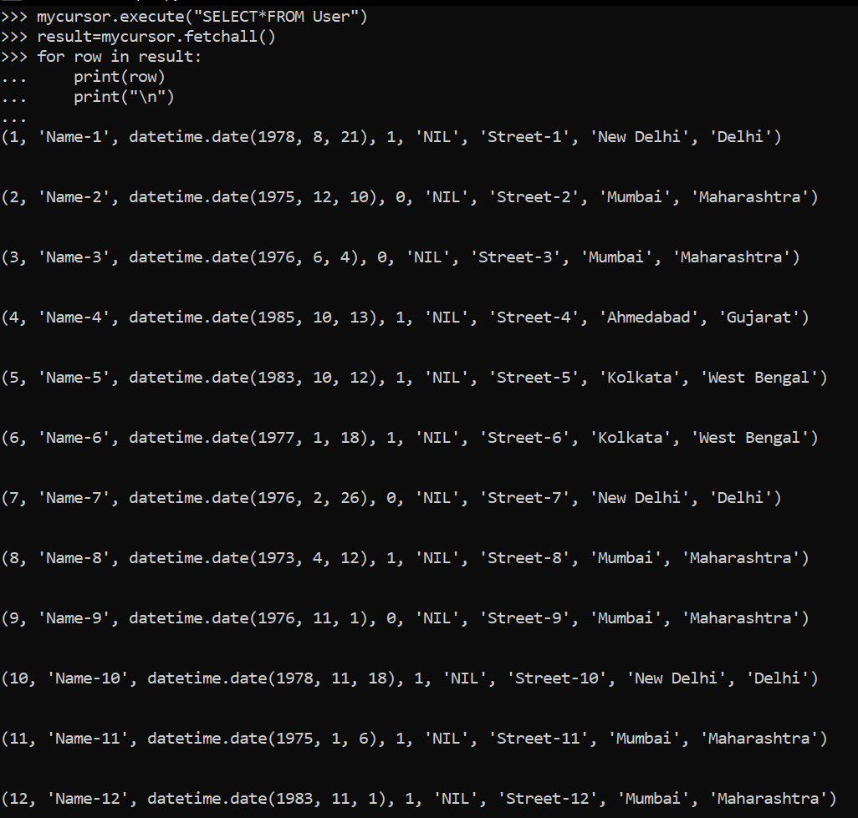

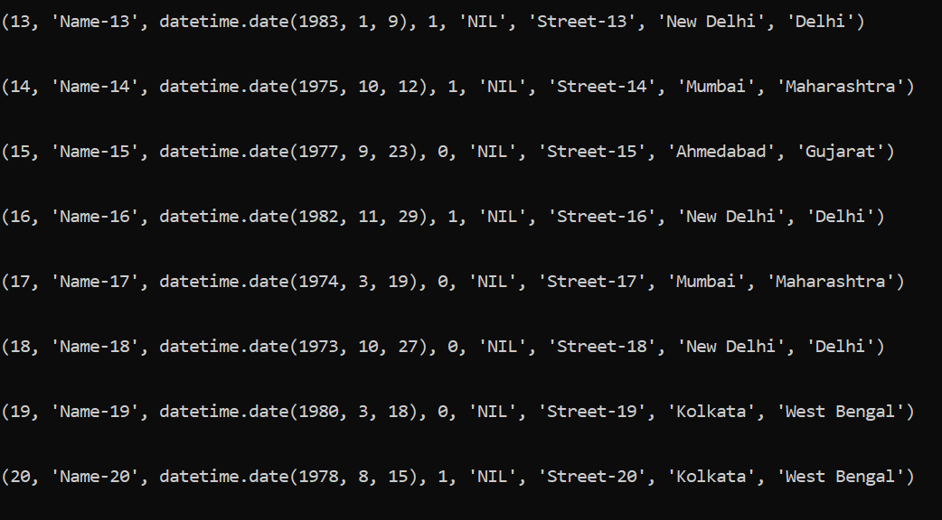

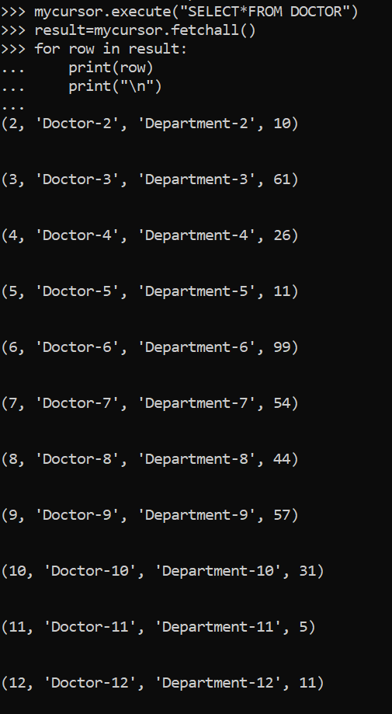

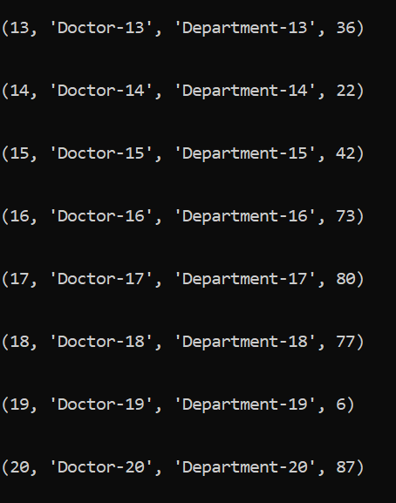

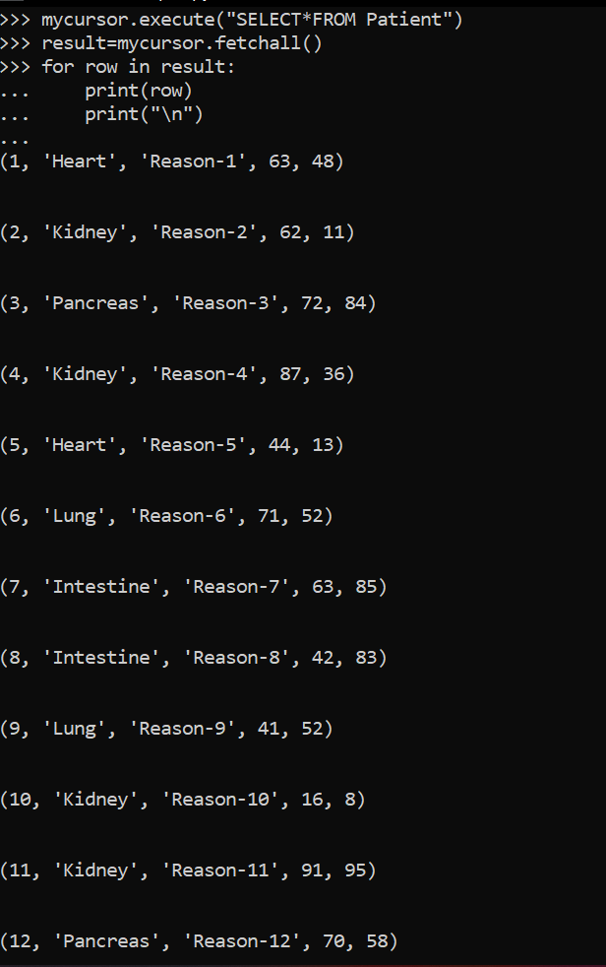

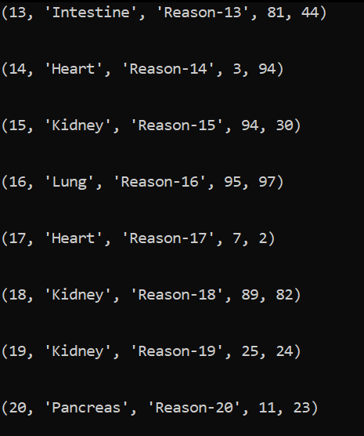

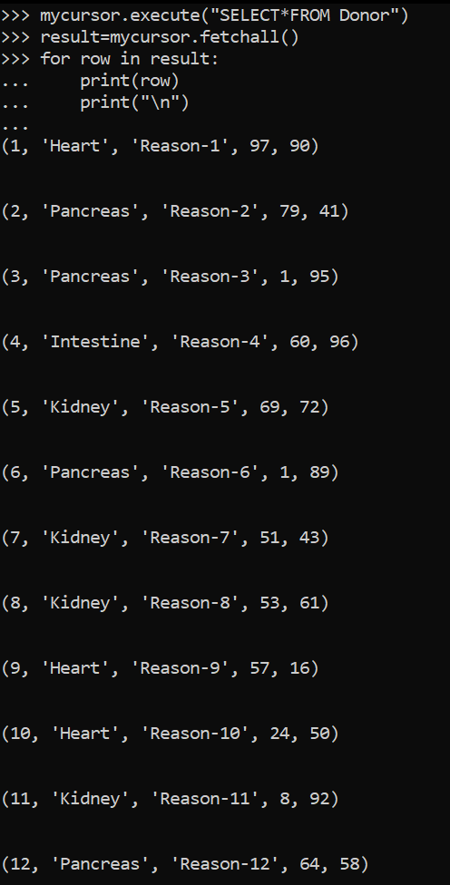

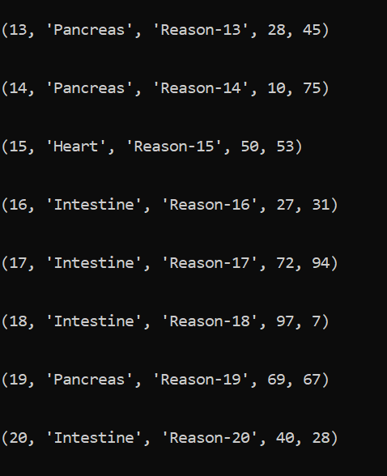

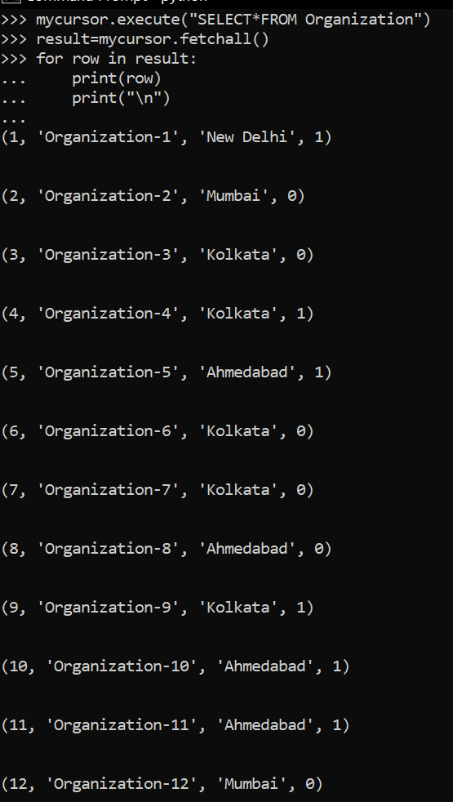

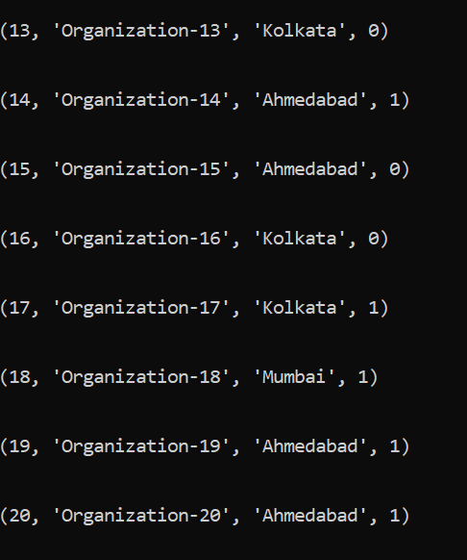

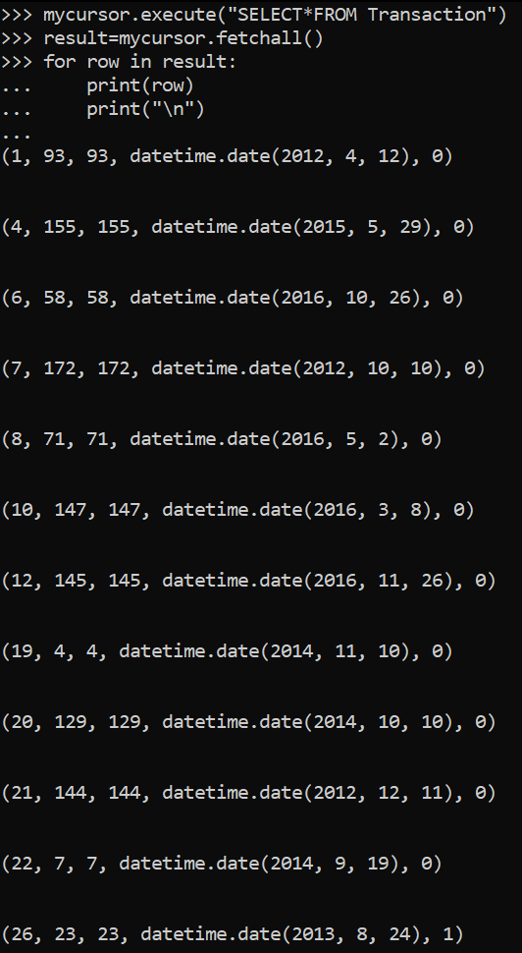

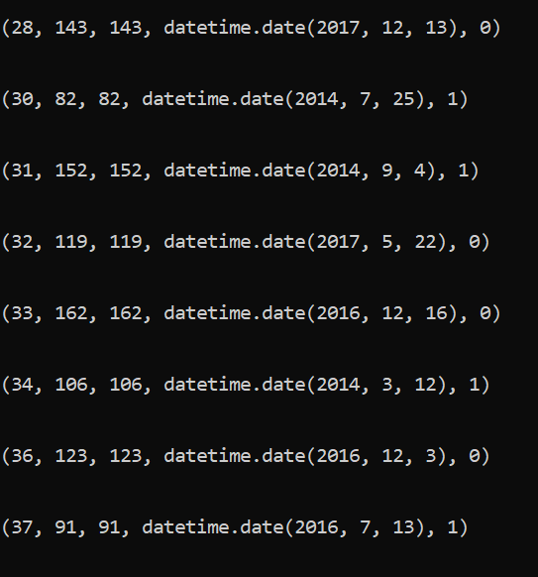

***QUERIES IMPLEMENTING OUR REQUIREMENTS IN PYTHON:***

*1.ADD NEW ENTRY TO DONOR TABLE:*

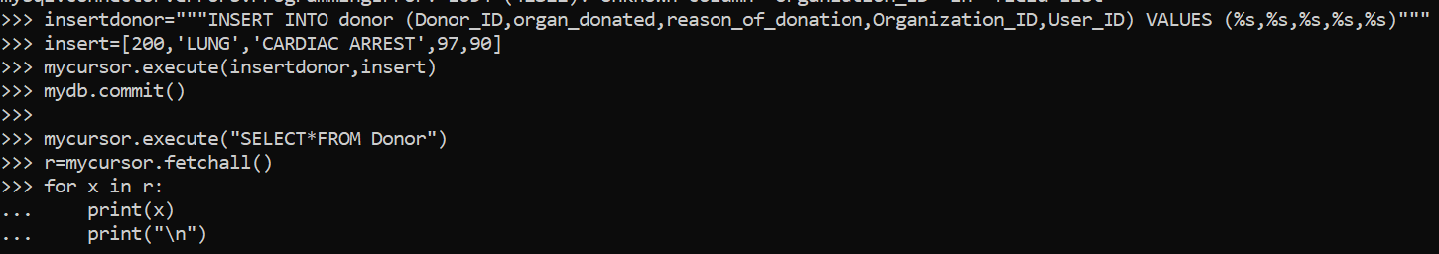

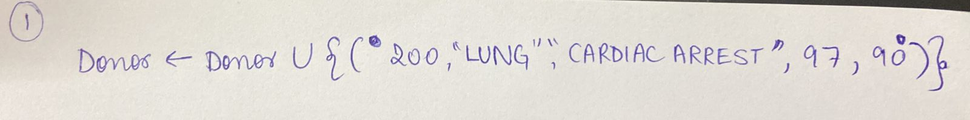

*2*. *FIND DONORS WHO WERE BRAIN DEAD:*

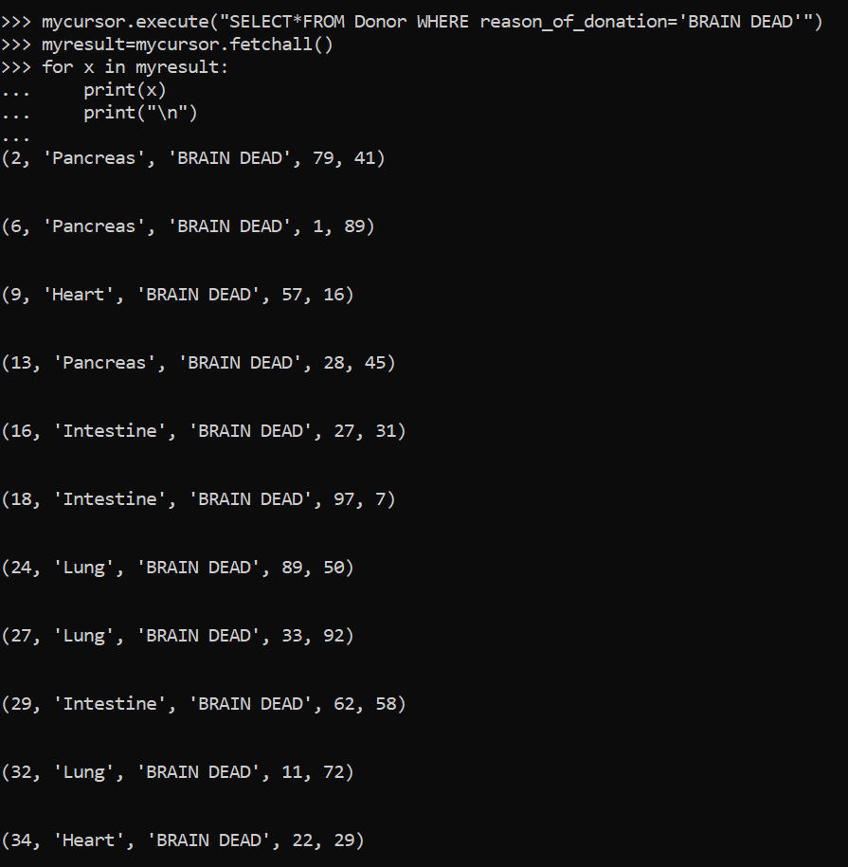

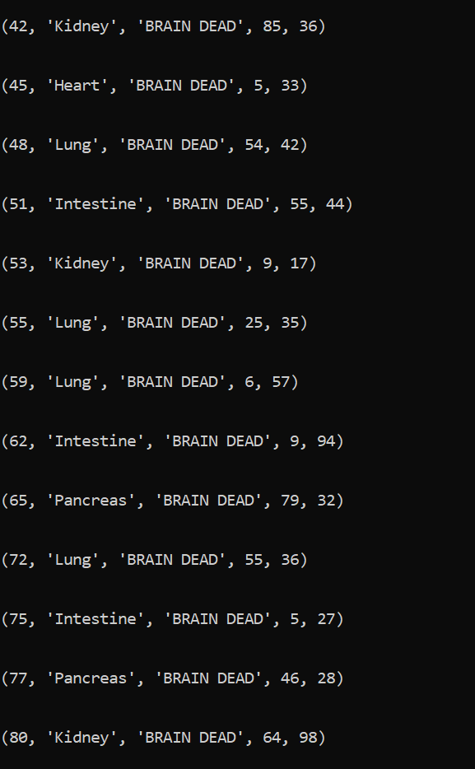

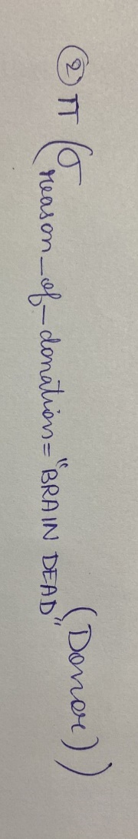

*3.* *FIND THE DONORS WHO DONATED THEIR KIDNEY WHERE THE REASON OF DONATION IS BRAIN DEAD*

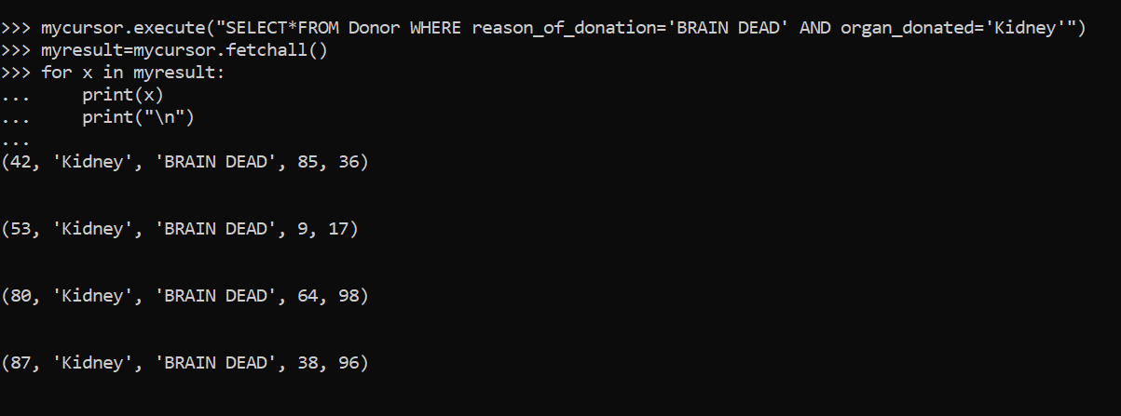

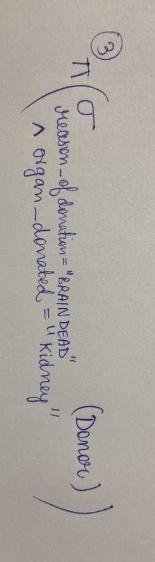

*4.* *FIND THE PATIENTS WHO NEED A LUNG TRANSPLANT WHO ALSO SUFFER FROM CANCER:*

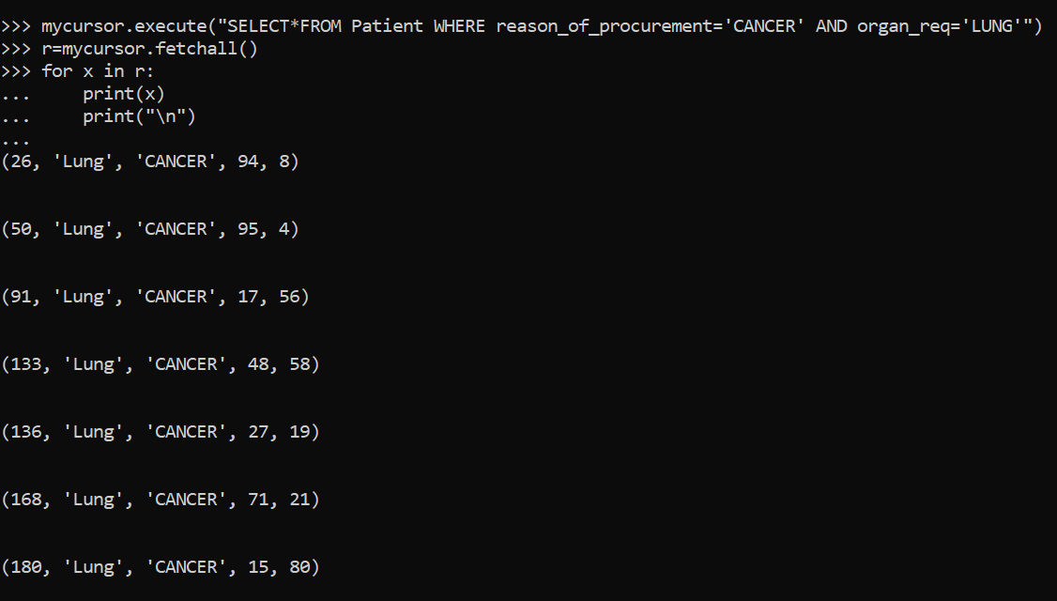

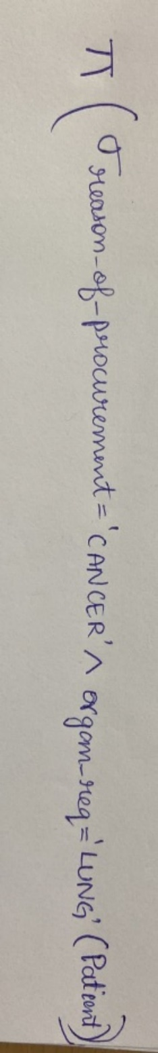

*5.LIST THE ROWS FROM THE PATIENT TABLE THAT HAS PATIENTS SUFFERING FROM PULMONARY FIBROSIS*

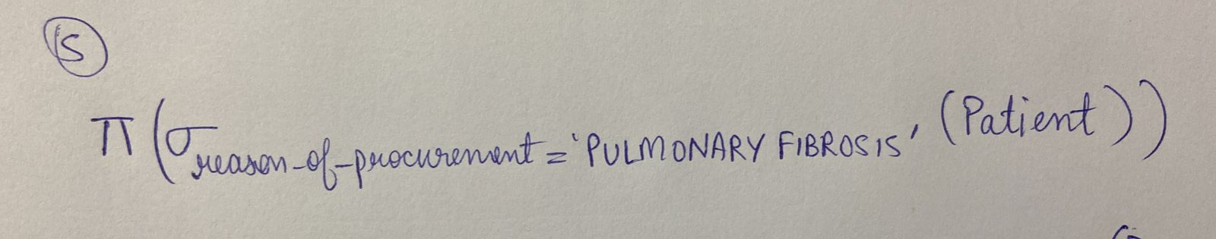

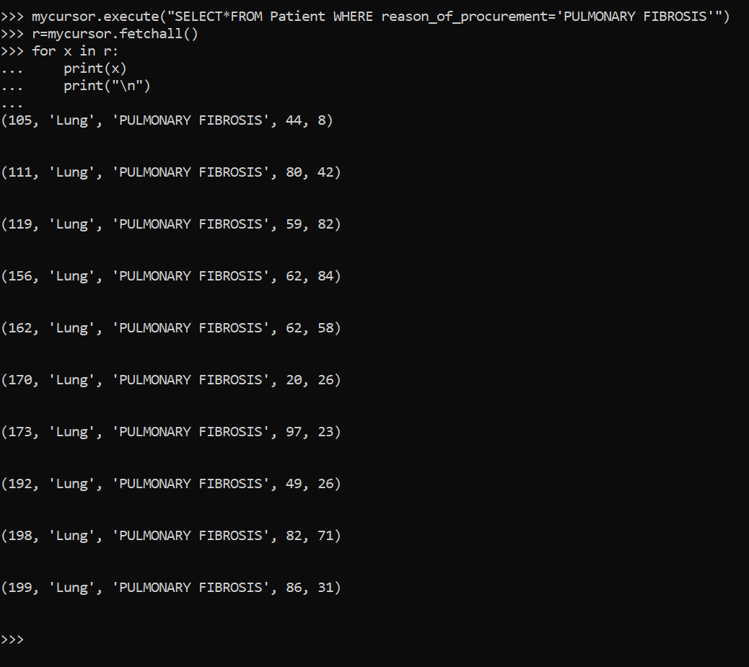

*6.* *LIST ALL THE DONORS WHO DONATED THEIR PANCREAS AFTER SUFFERING CARDIAC ARREST*

